SIMATS ENGINEERING
ASSESSMENT TOOL 3
COURSE NAME: Database Management Systems
COURSE CODE: CSA05

COURSE OUTCOME COVERED

CO2: Apply the relational model, relational algebra, SQL query structures, and views to solve database querying and data manipulation problems. (BL3, BL6)

Activity Tool : Debugging & Optimisation Task (Low)
Assessment Tool Weightage: 30%

Total Marks: 50
Q.No | Question | Bloom's Level | Marks
1 | Identify and fix the error in the given SQL query that uses incorrect JOIN syntax and returns duplicate results. | BL3 – Apply | 5
2 | The following sub-query returns incorrect results due to a missing correlation. Debug and rewrite it correctly. | BL3 – Apply | 5
3 | A given SQL view definition causes errors when queried. Identify the issue and rewrite a correct and optimized view. | BL3 – Apply | 5
4 | Debug the given relational algebra expression that produces incorrect output for a natural join operation. | BL3 – Apply | 5
5 | The SQL query below violates referential integrity. Identify the violation and modify the statements to enforce proper constraints. | BL3 – Apply | 5
6 | Given an inefficient SQL query with nested loops, rewrite it using JOIN to optimize performance. | BL6 – Create | 5
7 | The GROUP BY query below produces wrong aggregation results. Debug the query and explain the error. | BL3 – Apply | 5
8 | Identify and fix the logical error in a given SQL UPDATE statement that unintentionally modifies all rows in the table. | BL3 – Apply | 5
9 | Optimize the given multi-table SQL query by restructuring subqueries into JOINs and using appropriate indexes. | BL6 – Create | 5
10 | Debug a given relational calculus expression that returns an empty result set due to incorrect quantifier usage. | BL3 – Apply | 5
Code of Conduct:
I VISHAL KRUTHIK (192521179) certify that this submission is my original work and that I have adhered to the guidelines specified for this assessment.
I understand that any violation of academic integrity rules will result in disciplinary action.
Signature of the student:

RUBRICS FOR CALCULATION:
Criteria | Weightage | Level 4 (Exemplary) | Level 3 (Proficient) | Level 2 (Developing) | Level 1 (Beginning)
Problem Identification | 20% | Accurately identifies all errors and root causes with clear understanding | Identifies most errors with minor gaps | Identifies some errors but misses key issues | Unable to identify errors correctly
Debugging | 25% | Applies systematic debugging techniques effectively to resolve issues | Uses appropriate debugging methods with minor errors | Limited debugging approach; requires guidance | Unable to debug or resolve issues
Optimization | 20% | Optimizes code by significantly improving time complexity using efficient algorithms | Improves time complexity with minor gaps in efficiency | Limited improvement in time complexity | No improvement; inefficient approach retained
Analysis | 20% | Demonstrates strong logical reasoning and clear justification of solutions | Shows reasonable analysis with some justification | Limited analysis; weak reasoning | No analytical reasoning demonstrated
Code Quality | 15% | Produces clean, well-structured code with proper comments and documentation | Code is mostly clear with minor documentation gaps | Code lacks structure and proper documentation | Poorly written code with no documentation
SOLUTIONS / ANSWERS
CSA05 – Database Management Systems | Assessment Tool 3
Q1. Incorrect JOIN Syntax Causing Duplicate Results
Answer 1
Given (Buggy) Query
SELECT s.Name, c.CourseName
FROM STUDENT s, ENROLLMENT e, COURSE c
WHERE s.StudentID = e.StudentID
OR e.CourseID = c.CourseID;
Identified Error
The query mixes an old-style comma join with an OR instead of AND between the two join predicates. Because OR only requires one condition to be true, rows are matched even when StudentID and CourseID do not correspond to the same enrollment record, producing an implicit cross join and duplicate/incorrect rows.
Corrected Query
SELECT DISTINCT s.Name, c.CourseName
FROM STUDENT s
JOIN ENROLLMENT e ON s.StudentID = e.StudentID
JOIN COURSE c ON e.CourseID = c.CourseID;
Using explicit JOIN ... ON clauses with AND-style (one predicate per join) conditions ensures each pair of tables is matched correctly on its true relationship column, and DISTINCT removes any remaining duplicate rows caused by multiple enrollments.
Q2. Sub-query Missing Correlation
Answer 2
Given (Buggy) Query
SELECT EmpID, Name, Salary, DeptID
FROM EMPLOYEE e
WHERE Salary > (SELECT AVG(Salary) FROM EMPLOYEE);
Identified Error
The inner sub-query computes the average salary across the entire EMPLOYEE table, not per department. It is not correlated to the outer query's DeptID, so every employee is compared against one company-wide average instead of their own department's average — giving a misleading 'above average' result.
Corrected (Correlated) Query
SELECT EmpID, Name, Salary, DeptID
FROM EMPLOYEE e
WHERE Salary > (SELECT AVG(e2.Salary)
FROM EMPLOYEE e2
WHERE e2.DeptID = e.DeptID);
Adding the correlation condition e2.DeptID = e.DeptID re-evaluates the inner AVG() separately for each employee's own department, so the comparison is now meaningful.
Q3. Faulty SQL View Definition
Answer 3
Given (Buggy) View
CREATE VIEW HighValueCustomers AS
SELECT OrderID, CustomerID, SUM(Amount)
FROM ORDERS
GROUP BY CustomerID
HAVING SUM(Amount) > 5000;
Identified Error
OrderID is selected without being included in GROUP BY and without an aggregate function applied to it. Under strict SQL modes (e.g. ONLY_FULL_GROUP_BY) this raises an error, and even where it is allowed, the OrderID returned is arbitrary and not functionally meaningful per group.
Corrected and Optimized View
CREATE VIEW HighValueCustomers AS
SELECT CustomerID,
SUM(Amount) AS TotalAmount
FROM ORDERS
GROUP BY CustomerID
HAVING SUM(Amount) > 5000;
Dropping the non-aggregated OrderID column (which does not belong at the CustomerID grouping level) and aliasing SUM(Amount) makes the view both syntactically valid and semantically correct — one row per high-value customer.
Q4. Debugging a Relational Algebra Natural Join
Answer 4
Given (Buggy) Expression
Result = STUDENT x DEPARTMENT
(intended as a natural join on DeptID)
Identified Error
The expression uses the Cartesian product (x) directly, with no selection condition equating the common attribute DeptID. This pairs every STUDENT tuple with every DEPARTMENT tuple, producing |STUDENT| x |DEPARTMENT| rows instead of only the rows where departments actually match.
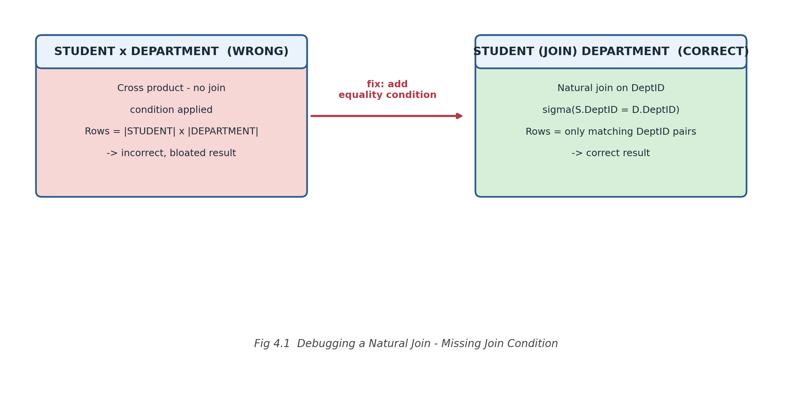
Corrected Expression
Result = STUDENT (natural join) DEPARTMENT
= pi(all distinct attributes)
( sigma(STUDENT.DeptID = DEPARTMENT.DeptID)
(STUDENT x DEPARTMENT) )
Applying a selection on the matching DeptID values before (or as part of) the join, and projecting out the duplicated join column, restores the correct natural-join semantics.
Q5. Referential Integrity Violation
Answer 5
Given (Buggy) Statements
CREATE TABLE ORDERS (
OrderID INT PRIMARY KEY,
CustomerID INT,
Amount DECIMAL(10,2)
);

INSERT INTO ORDERS VALUES (501, 999, 1500.00);
-- CustomerID 999 does not exist in CUSTOMER
Identified Violation
ORDERS.CustomerID has no FOREIGN KEY constraint linking it to CUSTOMER, so the INSERT succeeds even though CustomerID 999 does not exist — an orphan record that violates referential integrity.
Corrected Statements
ALTER TABLE ORDERS
ADD CONSTRAINT fk_orders_customer
FOREIGN KEY (CustomerID) REFERENCES CUSTOMER(CustomerID);

-- Now rejected until a matching CUSTOMER row exists
INSERT INTO ORDERS VALUES (501, 999, 1500.00); -- fails
INSERT INTO ORDERS VALUES (502, 1, 1500.00); -- succeeds
Adding the FOREIGN KEY constraint forces the database to reject any ORDERS row whose CustomerID does not already exist in CUSTOMER, enforcing referential integrity going forward.
Q6. Rewriting Nested Sub-queries as a JOIN
Answer 6
Given (Inefficient) Query
SELECT o.OrderID, o.CustomerID,
(SELECT c.Name
FROM CUSTOMER c
WHERE c.CustomerID = o.CustomerID) AS CustomerName
FROM ORDERS o;
Why It Is Inefficient
The correlated sub-query in the SELECT list is executed once for every row returned by ORDERS, behaving like a nested-loop lookup. On a large ORDERS table this results in one extra query per row instead of a single set-based operation.
Optimized Query Using JOIN
SELECT o.OrderID, o.CustomerID, c.Name AS CustomerName
FROM ORDERS o
JOIN CUSTOMER c ON o.CustomerID = c.CustomerID;
Replacing the per-row sub-query with a single JOIN lets the query optimizer plan one combined scan/lookup (often using an index on CUSTOMER.CustomerID) instead of thousands of individual sub-query executions.
Q7. Debugging a GROUP BY Aggregation Error
Answer 7
Given (Buggy) Query
SELECT DeptID, Name, AVG(Salary) AS AvgSalary
FROM EMPLOYEE
GROUP BY DeptID;
Identified Error
Name is selected without being part of the GROUP BY clause or wrapped in an aggregate function, yet the query groups only by DeptID. The database must pick an arbitrary Name for each group, so the result looks like a per-employee row but is really a per-department average — a misleading combination.
Corrected Query
SELECT DeptID, AVG(Salary) AS AvgSalary
FROM EMPLOYEE
GROUP BY DeptID;
Removing the non-aggregated Name column (which is not functionally dependent on DeptID) leaves a query that correctly reports one average-salary value per department.
Q8. UPDATE Statement Modifying All Rows
Answer 8
Given (Buggy) Statement
UPDATE EMPLOYEE
SET Salary = Salary * 1.10;
Identified Error
The UPDATE statement has no WHERE clause, so it applies the 10% raise to every row in EMPLOYEE rather than the intended subset (e.g. one department or a specific set of employees).
Corrected Statement
UPDATE EMPLOYEE
SET Salary = Salary * 1.10
WHERE DeptID = 10;

-- Best practice: verify first with a SELECT
-- SELECT * FROM EMPLOYEE WHERE DeptID = 10;
Adding the WHERE clause restricts the update to the intended rows. Running the equivalent SELECT first is a common safeguard before executing bulk UPDATE/DELETE statements.
Q9. Optimizing a Multi-table Query
Answer 9
Given (Unoptimized) Query
SELECT o.OrderID,
(SELECT c.Name FROM CUSTOMER c
WHERE c.CustomerID = o.CustomerID) AS CustName,
(SELECT p.ProductName FROM PRODUCT p
WHERE p.ProductID = o.ProductID) AS ProdName
FROM ORDERS o
WHERE o.OrderDate > '2026-01-01';
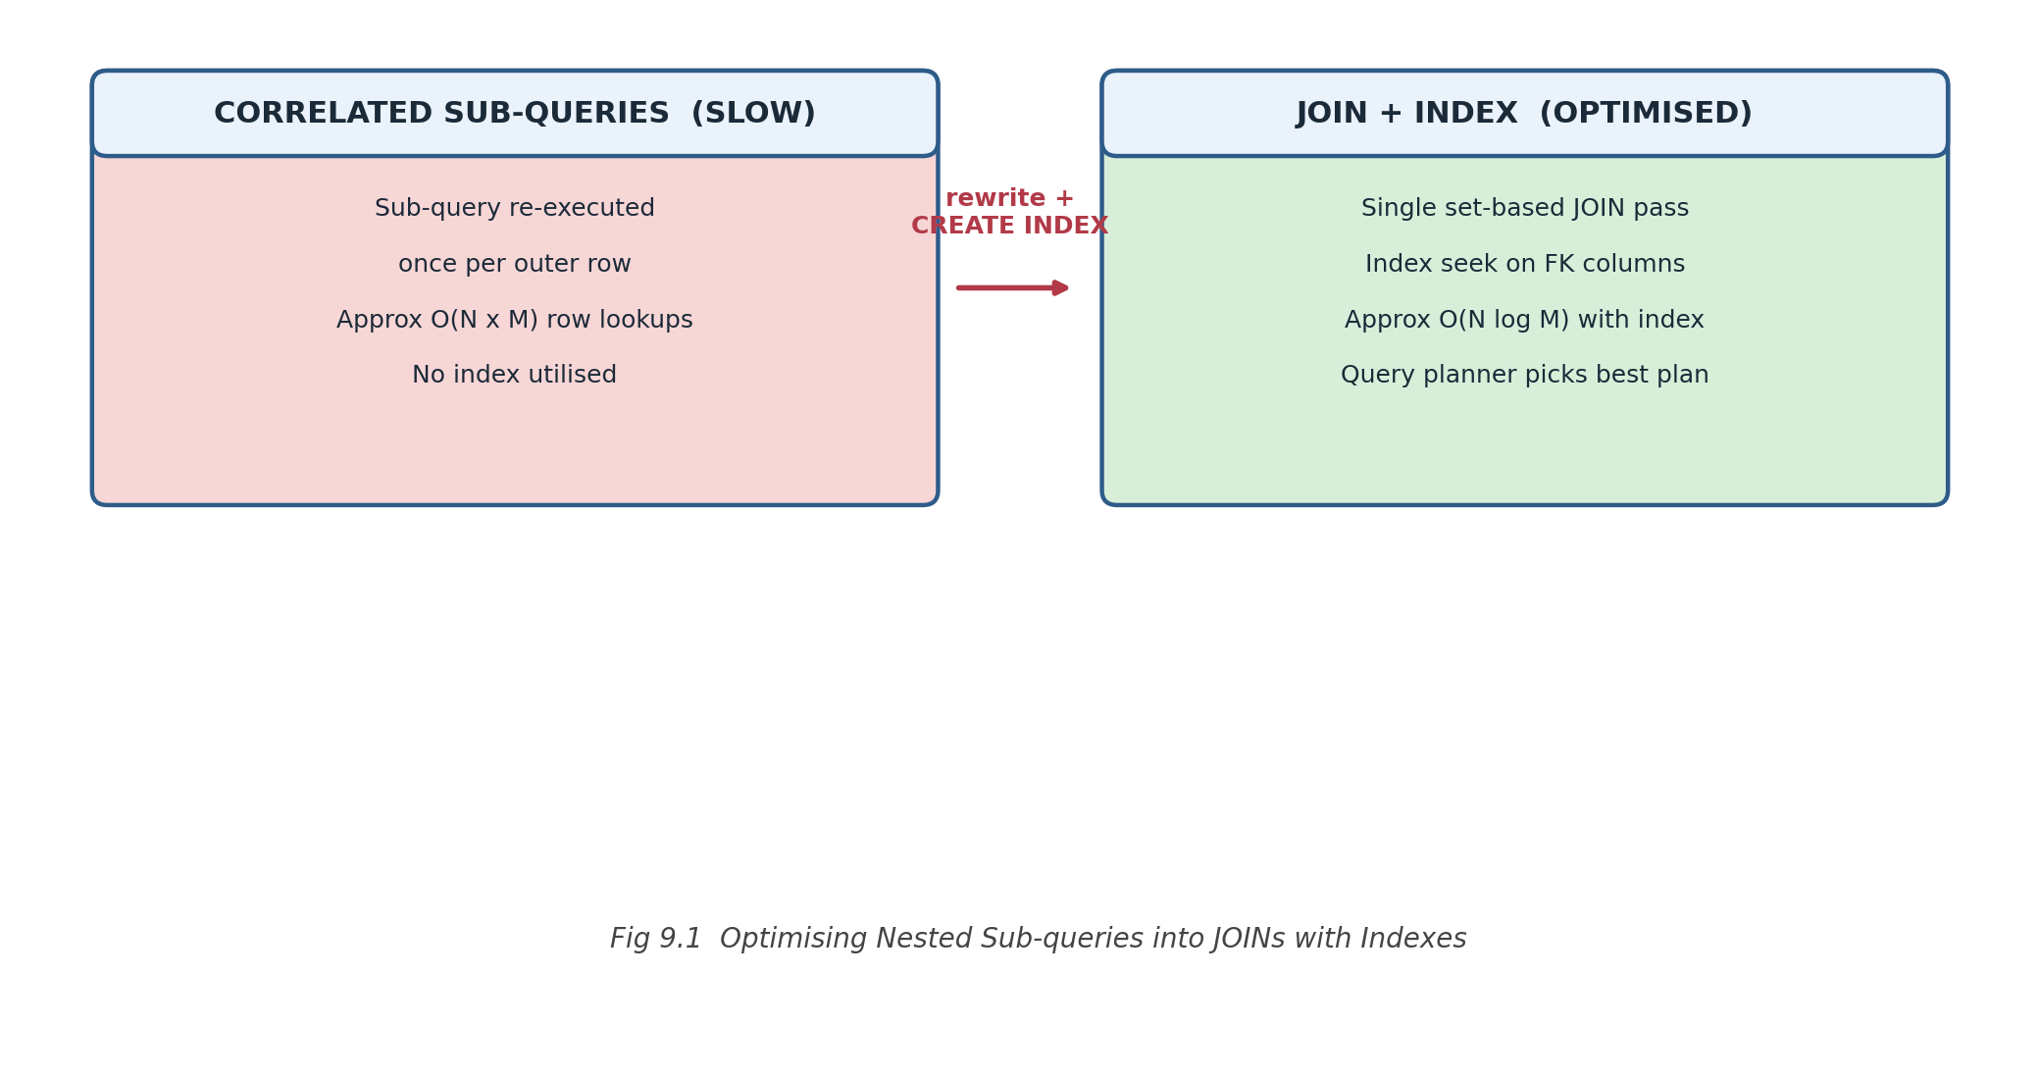
Optimized Query
SELECT o.OrderID, c.Name AS CustName, p.ProductName AS ProdName
FROM ORDERS o
JOIN CUSTOMER c ON o.CustomerID = c.CustomerID
JOIN PRODUCT p ON o.ProductID = p.ProductID
WHERE o.OrderDate > '2026-01-01';
Supporting Indexes
CREATE INDEX idx_orders_customerid ON ORDERS(CustomerID);
CREATE INDEX idx_orders_productid ON ORDERS(ProductID);
CREATE INDEX idx_orders_orderdate ON ORDERS(OrderDate);
Converting the two per-row sub-queries into JOINs allows the optimizer to use a single execution plan, and indexes on the FK/date columns let it seek matching rows instead of scanning CUSTOMER and PRODUCT repeatedly for every ORDERS row.
Q10. Debugging a Relational Calculus Quantifier Error
Answer 10
Given (Buggy) Expression
{ s | STUDENT(s) AND
FORALL c ( COURSE(c) -> ENROLLED(s, c) ) }
Identified Error
The universal quantifier (FORALL) requires a student to be enrolled in every single course in COURSE before qualifying. In practice almost no student enrolls in all courses, so the expression returns an empty result set — the intent was simply 'enrolled in at least one course'.
Corrected Expression
{ s | STUDENT(s) AND
EXISTS c ( COURSE(c) AND ENROLLED(s, c) ) }
Replacing FORALL with the existential quantifier EXISTS correctly returns every student who is enrolled in at least one course, matching the intended requirement.

